Table of Contents

Lab 1.1 RFQ……………………………………………………………………………..3
Lab 2.1 OUTLINE AGREEMENT………………………………………………………...5
Lab 3.1 INVOICING PLAN SETTLEMENT SCENARIO…………………………………..11

Lab: 1.1→ RFQ Process with price comparison and choosing best vendor

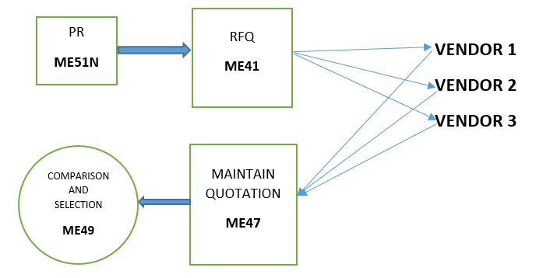

FIG 1.1: RFQ CYCLE

An RFQ is an external document used by a purchasing department to identify supplier
- ME41→ Create RFQ
In that we request to different vendors for quotation. We enter material, quantity and send it to different vendor.
  - Enter RFQ type as an (AN).
  - Enter the quotation deadline.
  - Enter purchase organization and purchase group.
  - Enter plant and storage location.
  - Enter the collective number to track of all RFQ’s.
  - Enter the appropriate item category, material number, RFQ quantity, delivery date, plant code.
  - Click on vendor address button on the tool bar and enter the vendor details.

- ME47→ Maintain RFQ
In that we enter the price for this particular vendor and material combination.
- Enter RFQ number.
- Enter RFQ quantity delivery date, net price, storage location.

- ME49→ Comparison And Selection of vendor
In that we select the best vendor.
- Enter purchase organization and collective no.

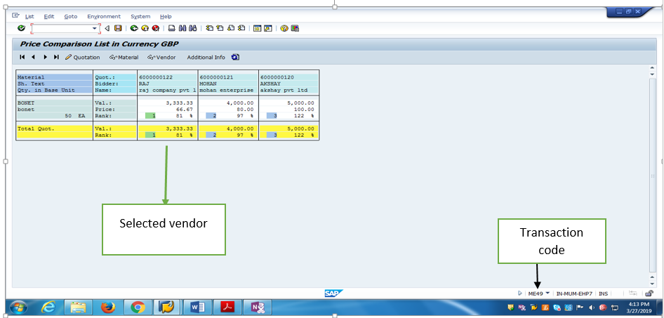
FIG 1.2: Price comparison view

You can compare the price from all quotation received by this price comparison process.
From this price comparison we select best vendor .

Lab 2.1→ Outline agreements contracts and scheduling agreements, scenario to be tested with your own data

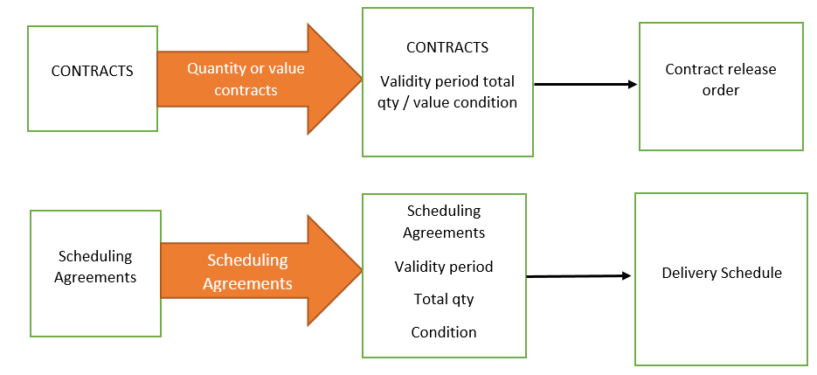

FIG 2.1 → Outline Agreement Flow

An Outline agreement is long term purchasing agreement with vendor with terms and condition.
Two type of outline agreement:-

1. Contract

2. Scheduling Agreement

CONTRACT
A: CREATE CONTRACT (ME31K)
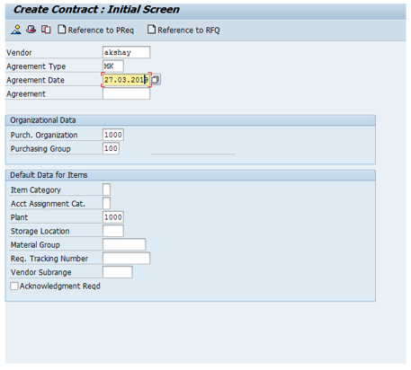

Fig 2.2→ Contract Initial Screen
B: Enter material data

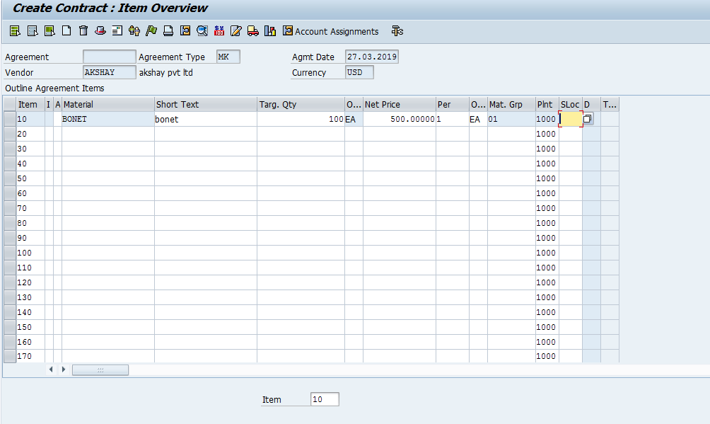
Fig 2.3→ Contract Item Overview screen

Then save it, contract number created→4600000018.

C: CREATE PURCHASE ORDER (ME21N)

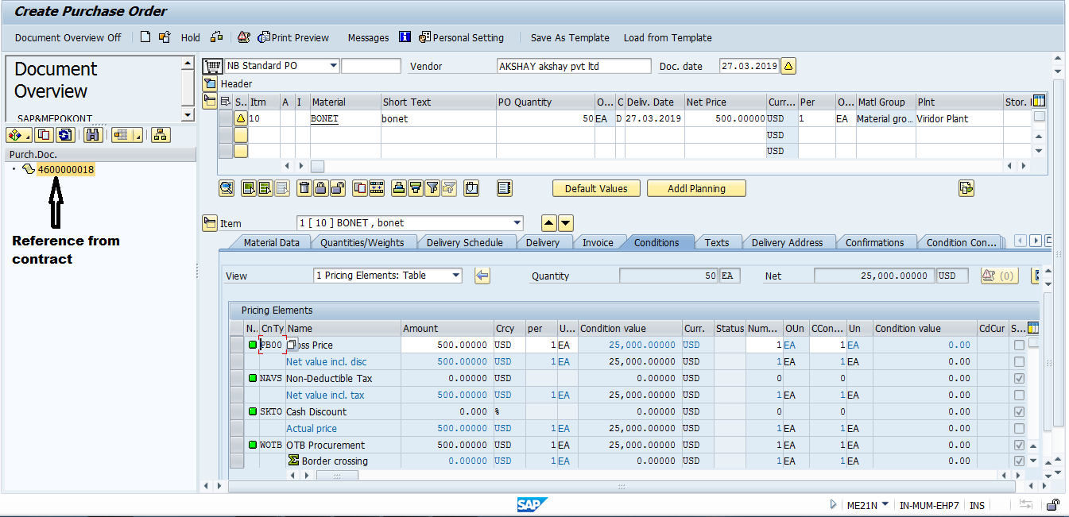

Fig 2.4→ Contract Release Order(4500000828)

D: INVOICE RECIEPT (MIRO)

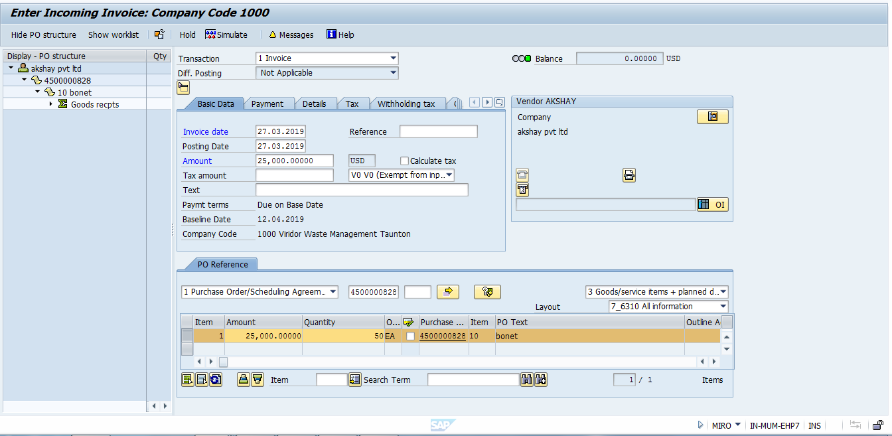

Fig 2.5 Invoice Receipt→ 5300000071

SCHEDULING AGREEMENT

A: Create scheduling agreement (ME31L)
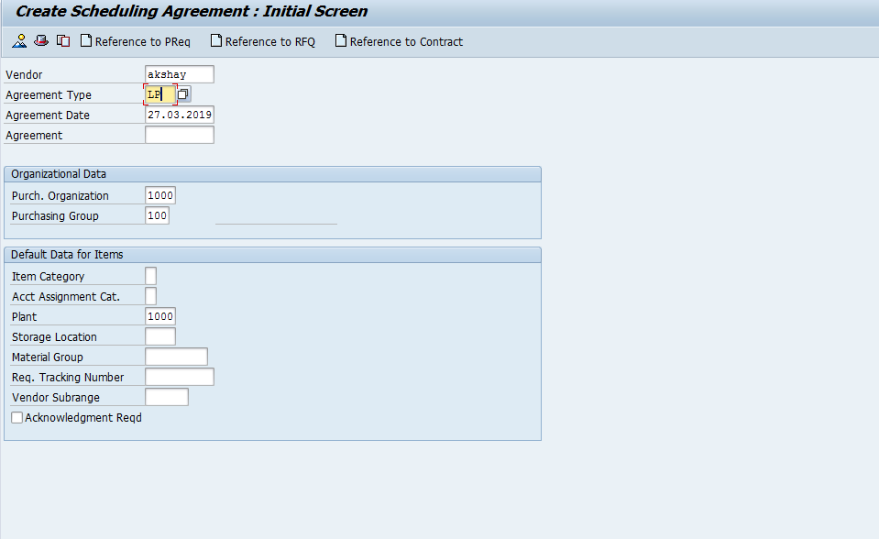

Fig 2.6: Initial Screen of create scheduling agreement

B: Maintain Delivery Schedule (me38)

In delivery schedule, maintain delivery date and schedule quantity

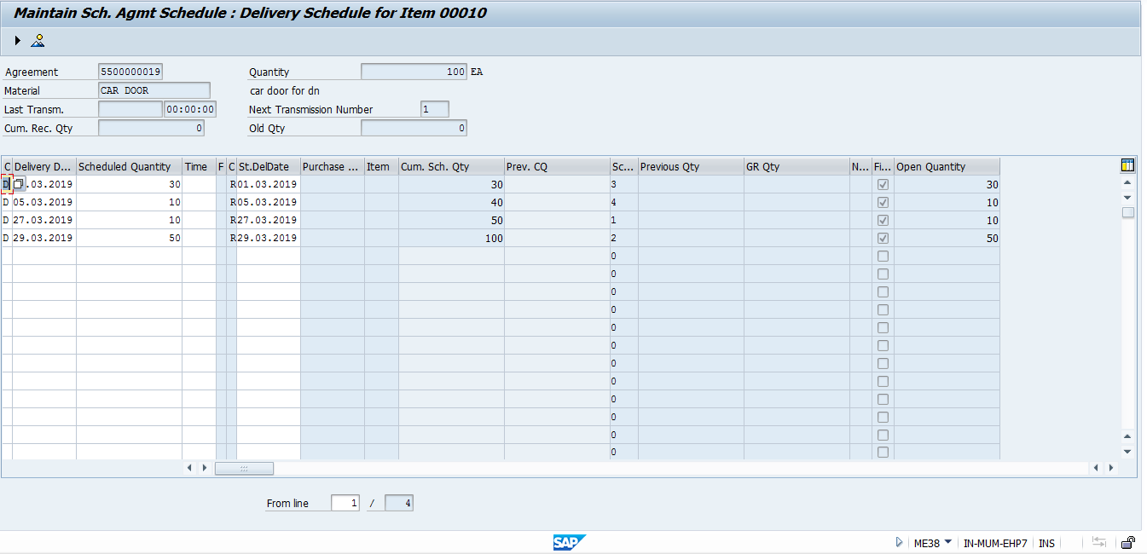

Fig 2.7: Manitain delivery schedule (5500000019)

C: Invoice with reference to scheduling agreement (MIRO)
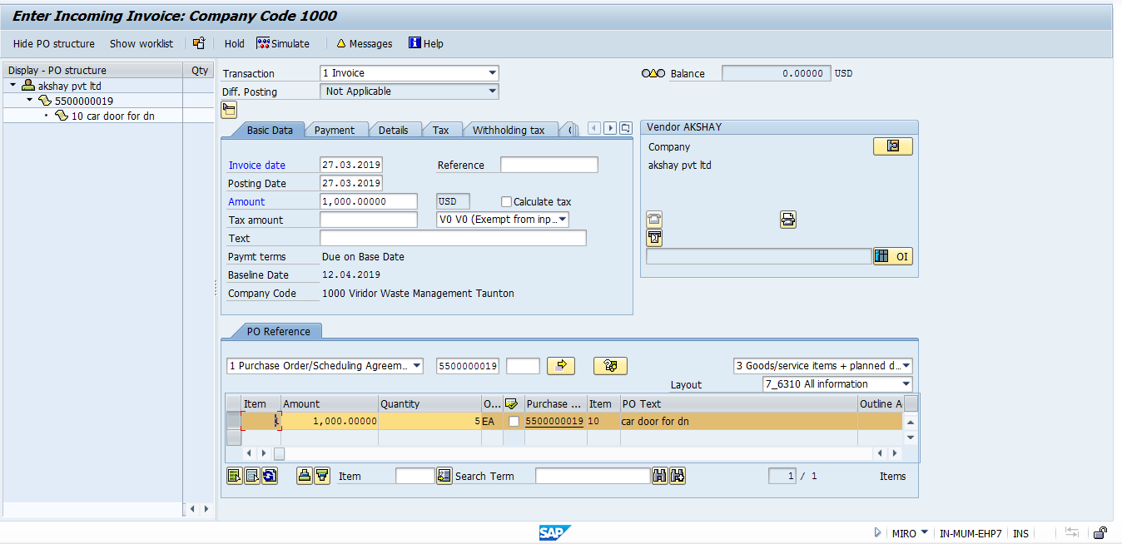
Fig 2.8: Scheduling agreement invoice (5300000072)

Lab 3.1→Invoicing plan scenario to be tested with background posting.

A: Create purchase order using document type frame work order (ME21N)

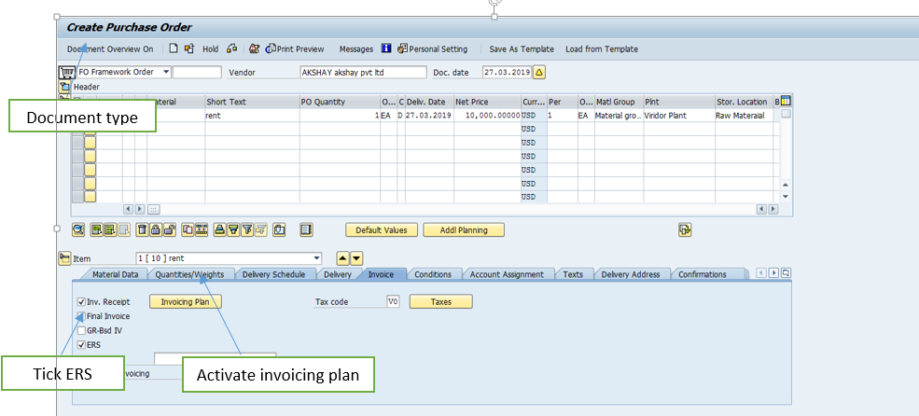

Fig 3.1 Framework PO

B: Click on the invoicing plan in invoice tab in item detail

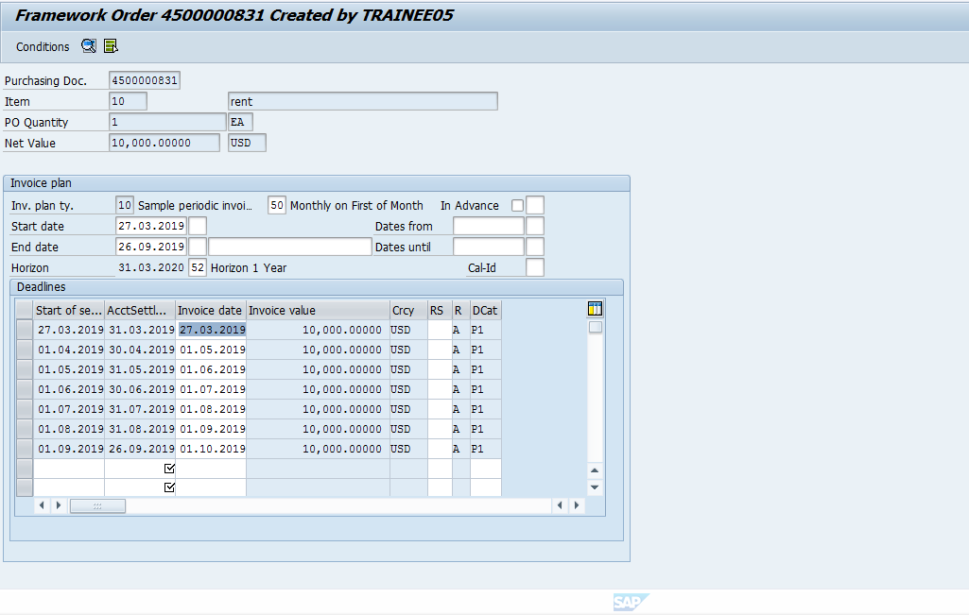
Fig 3.2: Invoicing plan Screen

C: Then do ERS settlement (MRIS)

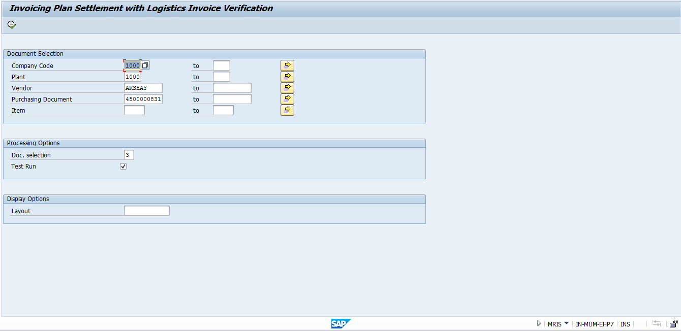
Fig 3.3: Invoicing settlement screen

D: Final invoicing settlement

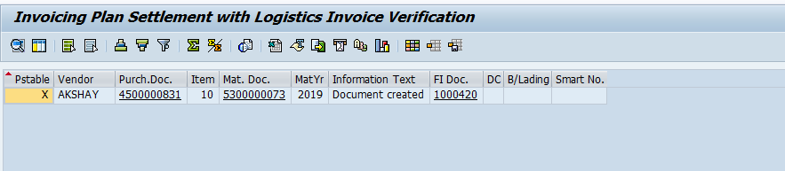
Fig 3.4: Invoicing settlement

